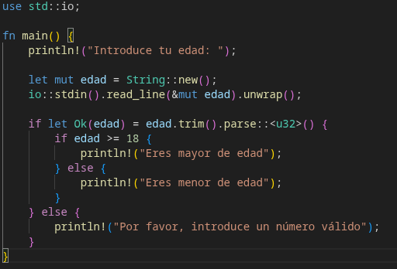
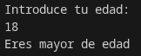
Ejecución normal

Error de sintáxis

* Executing task: cargo build --manifest-path="/home/Cargo.toml"

Compiling codigo v0.1.0 (/home/codigo)
error: unexpected closing delimiter: `}`
--> main.rs:18:1
|
9 | if let Ok(edad) = edad.trim().parse::<u32>() {
| - this delimiter might not be properly closed...
...
14 | }
| - ...as it matches this but it has different indentation
...
18 | }
| ^ unexpected closing delimiter

error: could not compile `codigo` (bin "codigo") due to 1 previous error

* The terminal process "/usr/bin/bash '-c', 'cargo build --manifest-path="/home/Cargo.toml"'" failed to launch (exit code: 101).
* Terminal will be reused by tasks, press any key to close it.
Aquí podemos ver que da error en la compilación en modo debug, no se ejecuta nada.
(hemos quitado una llave)

